

**Netcare Kingsway Trouble Shooting Session**

Focus Session was established to unify key support resources

* BCX VOICE
* Networks
* Alcatel PABX

To Help and assist in resolving customer Complaint around telephony Audio quality

Primary Problem experienced by Netcare telephony users is no Audio or one way audio

This was reported 2023/04/26 to 031 904 7056 had received multiple calls with NO Audio this directly led to a Focused Investigation and troubleshooting session

**Investigation**

This consisted of doing a battery testing and data capturing

* Multiple calls were made from different service providers and telephony systems
* Each call was answered, and voice quality was measured by called and calling as well as using industry standard MOS scoring

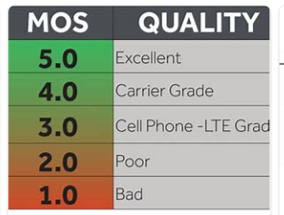

**Test Results**

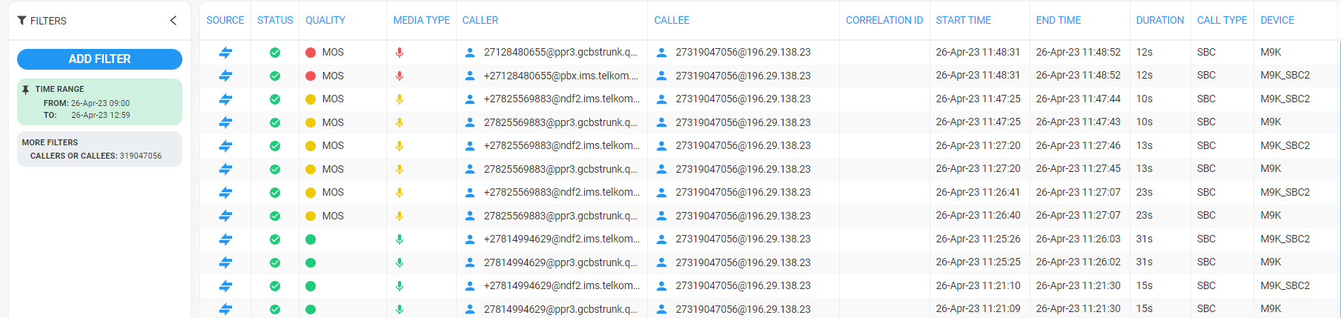

**Data Analysis**

From all the calls made all had bidirectional audio acceptable MOS score 3.0-3.9

Tools for collection Data

* Wireshark
* OVOC

Data repositories

* Remote desktop server
* Router
* OVOC

Data was Collected at two Point

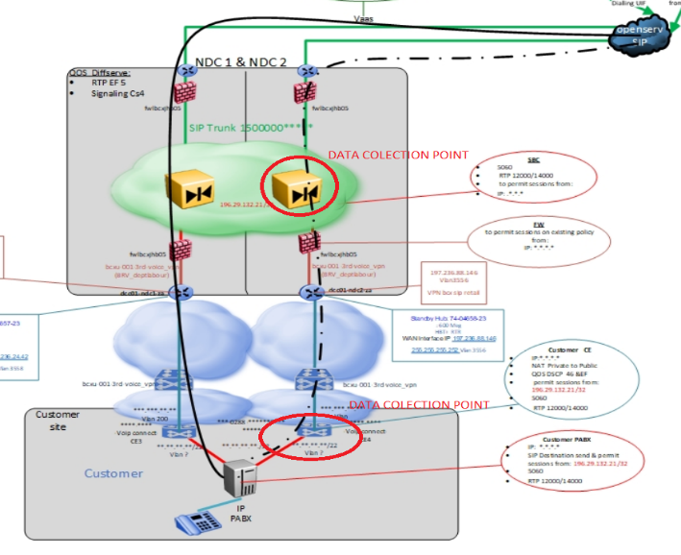

**Trouble shooting**

No trouble shooting has been implemented as there has been no changes made to any of the equipment

**Conclusion**

As these where done pre long weekend we suspect that normal voice traffic trend and volumes

Where biased

All the test results were deemed successful by the panel on the focus session

**Next Steps**

* Setup more data collection point
* Increase time period for data collection
* Increase Testing barometer